Performance And Testing
Date | 31 OCTOBER 2025
Team ID | NM2025TMID04230
Project Name | Education Organisation Using ServiceNow
Maximum Marks | 4 Marks

Model Performance Testing
Adding Admission For Student
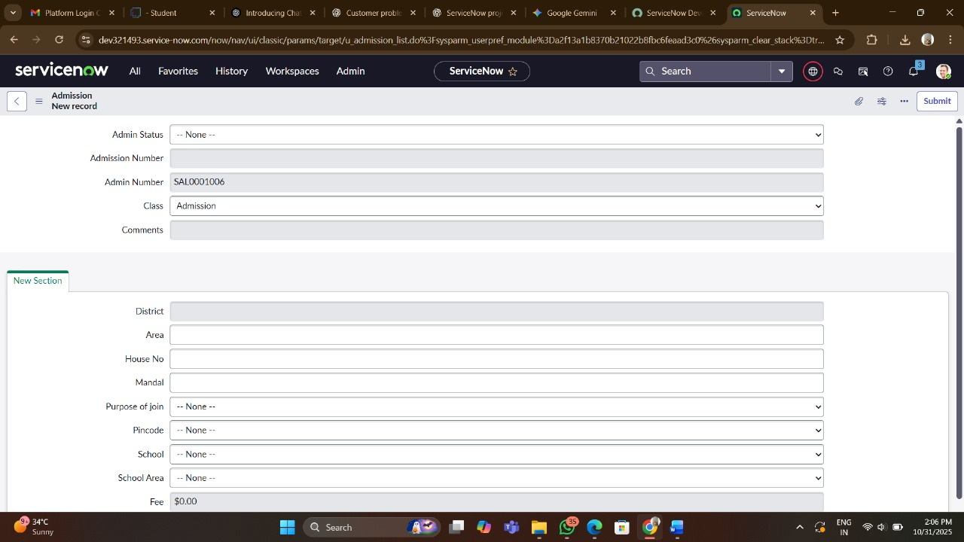

Parameter | Description
Admission Number | A unique identifier assigned by the system for this specific admission record. (Example shown: SAL001006).
Admin Status | The current stage or administrative status of the admission process. Possible values include 'New,' 'In Progress,' 'Pending Review,' 'Approved,' or 'Rejected.'
Fee | The amount of the initial admission or application fee associated with this record. (Value shown: $0.00, indicating an entry is pending or it's waived).
Purpose of Join | The student's stated primary reason or goal for joining the educational organization (e.g., 'Higher Education,' 'Skill Development').
Comments | A free-text field for notes, remarks, or special instructions related to the student's admission or any actions taken by staff.

Adding Salesforce For Student
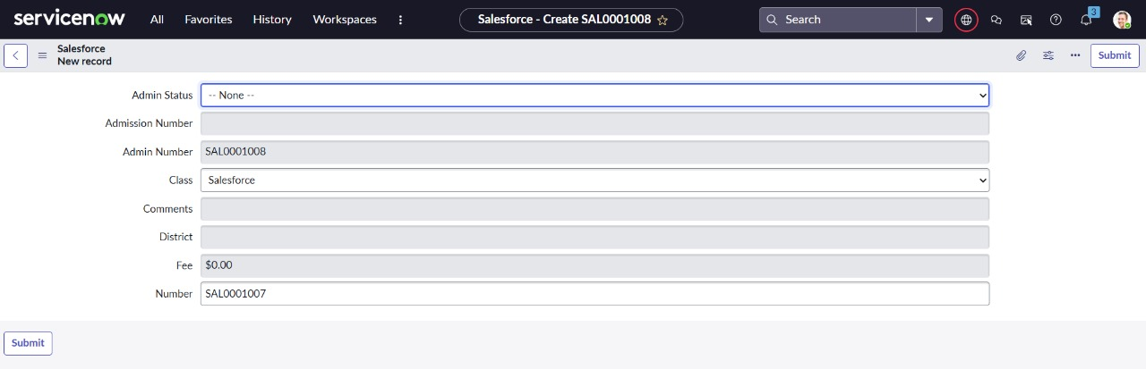

Parameter | Description
District | The geographical or administrative district associated with the student, such as their residential district or the district of a previous school.
Number | Another unique identifier, likely a record number for the underlying ServiceNow table. This might be the system's internal ID for the record, distinct from the Admission Number which could be business-facing.
Admission Number | A unique identifier for this specific admission application or record. Often automatically assigned by the system.
Admin Status | The current administrative status of the admission record. This tracks the progress of an applicant through the admission pipeline.

Adding Salesforce For Student
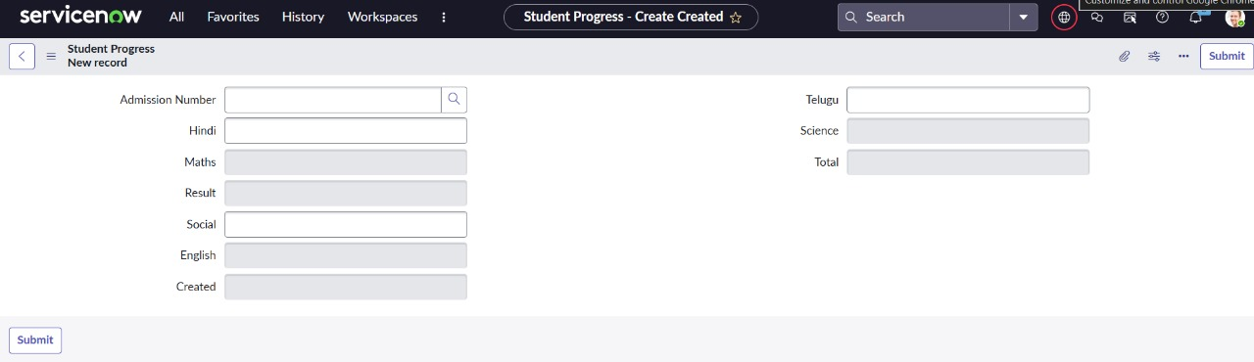
Parameter | Description
Admission Number | A unique identifier for the student, linking this progress record back to a specific student's admission or enrollment. The magnifying glass indicates it's likely a reference field to a Student or Admission table.
Hindi | The score or grade achieved by the student in the Hindi language subject.
Total | The total score or sum of grades across all listed subjects for the student. This would likely be a calculated field.

